You’re in the army now!
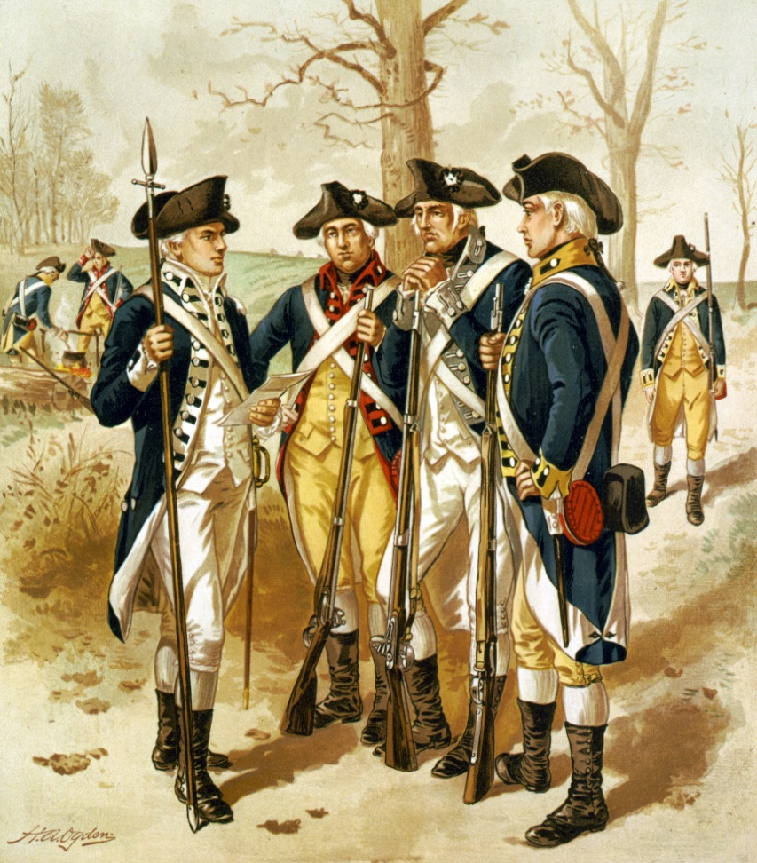

Valley Forge: Would you have quit?

__________________’s
Field Notes

